Down Payment in Asset Accounting

- Create Down Payment Request F-47

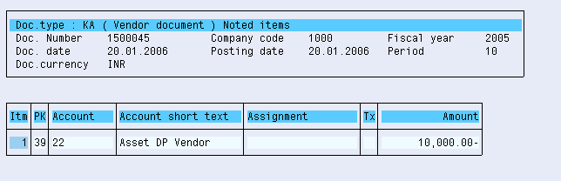

- Down Payment Made F-48

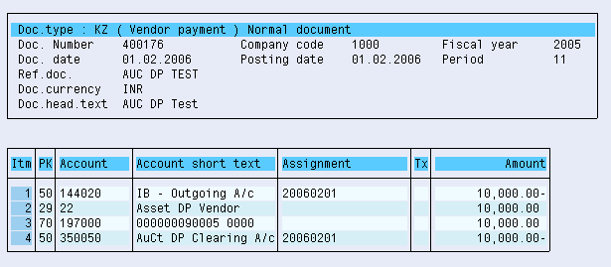

3. Asset Acquisition F-90

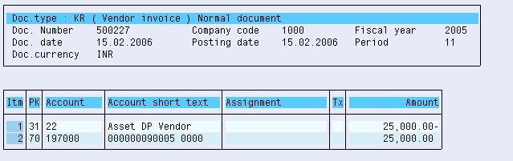

4.Down Payment Clearing F-54

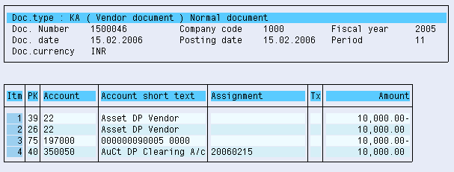

5. Vendor Account FBL1N

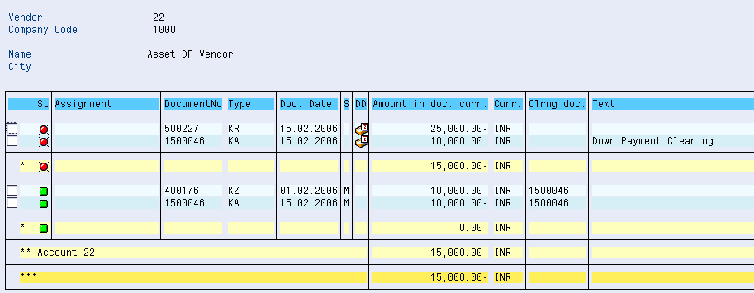

6. AuC AW01N

